Parents and Players,

Having a strong fundraiser is an important start to a successful season. This season we are excited to be partnering with Team Up Banners! This partnership will help us raise the critical funding we need, give significant exposure to community businesses and provide our team with a custom 4' x 8' team banner that we can proudly hang on our fence.

Sample banner:

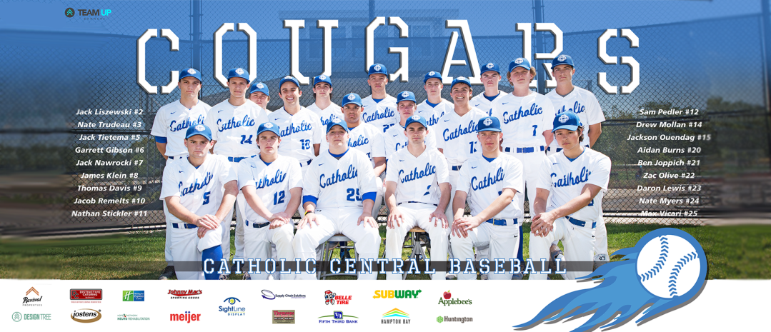

I am asking each player to find one business to sponsor our team banner. In exchange for a $300 sponsorship the business will have their logo prominently placed on our banner (as shown above).

Each player is being provided flyers, template emails, and a sample social media post that can be used to approach potential sponsors. Each of the promotional items direct the sponsor to TeamUpBanners.com where the sponsor will choose our team, choose the player they are sponsoring and pay for the sponsorship. The only thing each player is asked to do is find a sponsor. Team Up Banners will handle everything else (payment, receipt, logo, etc.) directly with each sponsor.

Please have your sponsorships secured by August 25th.

I really appreciate everything each of you do for our program!

Go BUCKS!

Coach Philip

